Unemployment rate data summary for female

|  |  |  |  |  |  |
| --- | --- | --- | --- | --- | --- |
| GEO | Mean Unemployment | Median Unemployment | Standard Deviation | Minimum Unemployment | Maximum Unemployment |
| Alberta | 8.107407407 | 7.6 | 2.62584052 | 4.7 | 15.9 |
| British Columbia | 6.209259259 | 5.25 | 2.220425636 | 4.2 | 13.1 |
| Canada | 7.02962963 | 6.1 | 2.178334973 | 5 | 14.1 |
| Manitoba | 6.096296296 | 5.7 | 1.80763193 | 3.7 | 11.8 |
| New Brunswick | 9.861111111 | 9.6 | 1.855986405 | 6.3 | 15.1 |
| Newfoundland and Labrador | 15.15185185 | 14.6 | 2.744582364 | 11.2 | 23.7 |
| Nova Scotia | 8.812962963 | 8.6 | 1.80031929 | 5.2 | 13.8 |
| Ontario | 7.022222222 | 5.85 | 2.208103999 | 4.8 | 13.7 |
| Prince Edward Island | 9.974074074 | 10.1 | 1.743579617 | 4.9 | 13.4 |
| Quebec | 6.211111111 | 5.55 | 2.530468423 | 4 | 18.5 |
| Saskatchewan | 6.52962963 | 6 | 1.711407854 | 4.6 | 12.4 |

Unemployment rate data summary for male

|  |  |  |  |  |  |
| --- | --- | --- | --- | --- | --- |
| GEO | Mean Unemployment | Median Unemployment | Standard Deviation | Minimum Unemployment | Maximum Unemployment |
| Alberta | 8.107407 | 7.6 | 2.625841 | 4.7 | 15.9 |
| British Columbia | 6.209259 | 5.25 | 2.220426 | 4.2 | 13.1 |
| Canada | 7.02963 | 6.1 | 2.178335 | 5 | 14.1 |
| Manitoba | 6.096296 | 5.7 | 1.807632 | 3.7 | 11.8 |
| New Brunswick | 9.861111 | 9.6 | 1.855986 | 6.3 | 15.1 |
| Newfoundland and Labrador | 15.15185 | 14.6 | 2.744582 | 11.2 | 23.7 |
| Nova Scotia | 8.812963 | 8.6 | 1.800319 | 5.2 | 13.8 |
| Ontario | 7.022222 | 5.85 | 2.208104 | 4.8 | 13.7 |
| Prince Edward Island | 9.974074 | 10.1 | 1.74358 | 4.9 | 13.4 |
| Quebec | 6.211111 | 5.55 | 2.530468 | 4 | 18.5 |
| Saskatchewan | 6.52963 | 6 | 1.711408 | 4.6 | 12.4 |

Data visualization of Unemployment rate from 2019-2023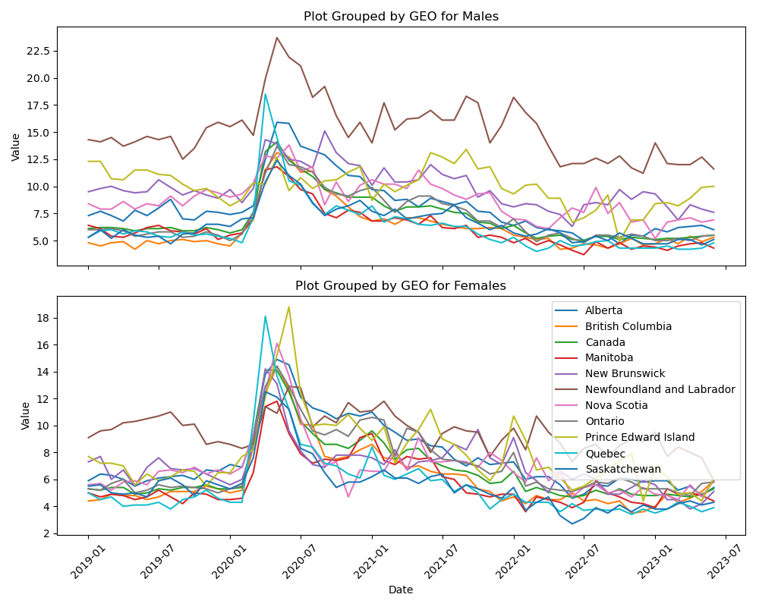

Hypothesis Testing about if there’s a difference between unemployment rate of Male and Female in the region of Canada.

Output:

p_value = 0.3335291231595887

There is no significant difference in unemployment rates between male and female.

Data visualization of Covid-19 average case rate (last 7) from Feb 2020-July 2023

